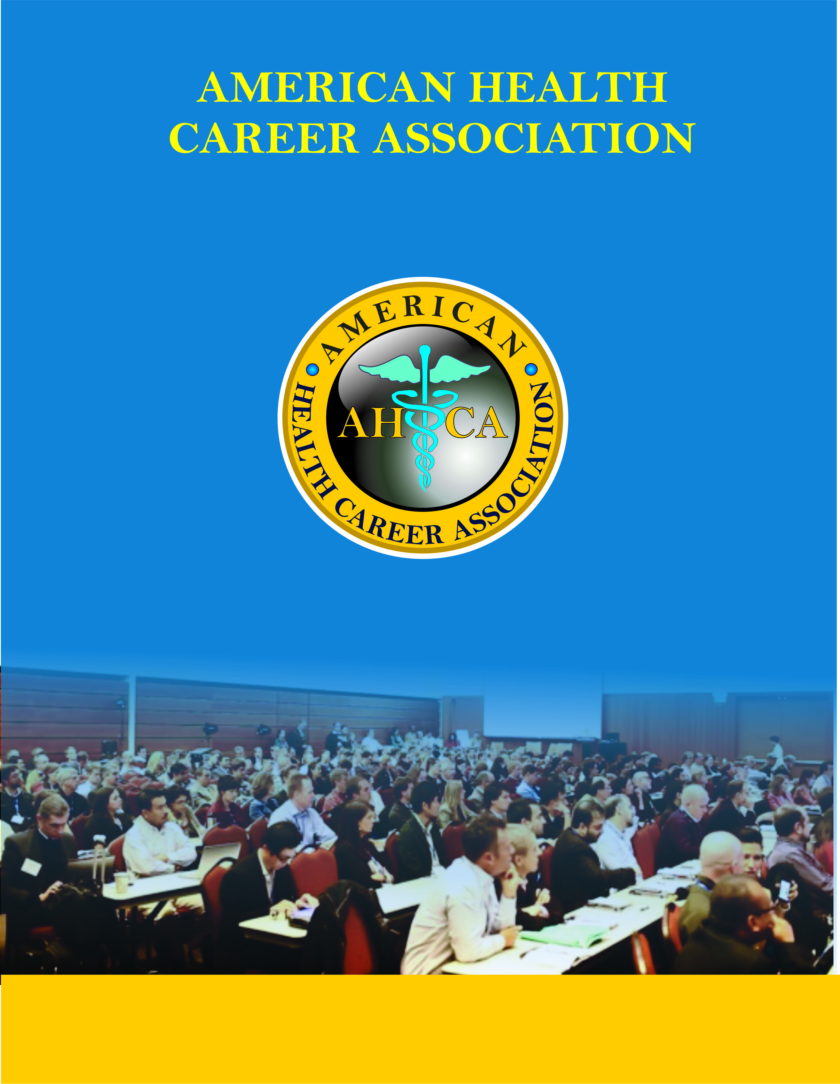
SERVING PUBLIC INTEREST

4200 Cantera Dr, Suite 108,
Warrenville, IL 60555, USA.

Program Approval Manual

Table of Contents

Education Program Approval Manual | Page #
What is approval | 2
The approval review process | 3
Curriculum plan | 4
Review Process | 5
Withholding of approval | 6

PROGRAM APPROVAL MANUAL

This manual is to present guidelines for education programs wishing to seek
AHCA Approval.

APPROVAL
Approval is a process of external peer review in which an agency grants public
recognition to a program of study that meets established qualifications and
educational standards. Participation in an approval process is voluntary since
there is no legal requirement for specialized programs to participate. The
Approval Process under AHCA is a paper peer review process.

What is Program Approval?
The AHCA, in recognizing a quality education program, has developed a process
by which organizations providing vocational education can be peer reviewed
against a minimum set of standards for entry-level professionals. This process
allows academic institutions, healthcare organizations, and private companies to
be acknowledged as offering an AHCA Approved Program.

These programs must also meet additional educational and organizational ‘best
practice’ criteria as established by the AHCA. The Approval Program is specific
to vocational program that are non-degree granting but conclude with a certificate
of completion. Several factors make Approval valuable including but not limited to
the following:

- Identifies for the public specialized programs that meet established
standards of educational quality.

- Stimulates improvement of educational standards by involving faculty and
staff in self-evaluation and planning.

- Promotes a better understanding of the goals of professional certificate
education.

4. Provides reasonable assurance that practitioners possess the necessary
job skills upon entry into the profession.

- Assists specialized programs in achieving their objectives.

THE APPROVAL REVIEW PROCESS

Any program applying for Approval must complete the following steps:

STEP I: LETTER OF INTENT

A letter of intent to apply for Approval should be sent to the Education
Department of AHCA.

STEP 2: REPORT FOR APPROVAL
The program sponsor will be notified by AHCA upon review of the synopsis of
curriculum, as to suitability and timetable to proceed to Step 2. Comments
regarding the curriculum will be provided to the sponsor at that time. A formal
written report for an education program must be submitted to the Education
Evaluation of AHCA.

Programs must review and incorporate the minimum curriculum requirements for
the development and evaluation of the program.

Approval Committee for Certificate Programs (ACCP) formulates decision and determines Approval Award Decision

Program Submits Application and Self-Study Report.

Program is notified of Approval Award Decision.

Peer Review of all Report materials.

Approval Criteria for Certificate Programs:

A. The organization offering program instruction (academic institution, healthcare organizations, private companies, etc.) must ensure that:

1. The program has been in existence a minimum of six months;

2. Instruction follows established guidelines and practices;

3. Non-discriminatory practices with respect to race, color, creed, sex, age, disabling conditions (handicaps), and national origin are practiced;

C. The organization must clearly indicate the intended competencies and outcome of the program offered.

D. The Curriculum Plan must include:

1. The curriculum must include the knowledge clusters.

2. Appropriate course content must be reinforced by structured practice
experiences to apply learned principles.

3. Course content and curriculum sequencing must be established in
accordance with recognized educational principles, to develop the
competencies necessary for entry-level practice.

E. Clearly written course material (syllabi) must be provided to the student,
which clearly describes course learning objectives and supervised
professional practice assignments to be achieved, the frequency of testing
and other documented student evaluation and the competencies required
for completion.

F. Testing methods (evaluation systems) must include content related to the
objectives and competencies described in the curriculum for both didactic
and supervised professional practice education components. They must
be employed frequently enough to provide timely feedback of the students’
progress and to serve as a reliable indicator of the effectiveness of course
design and instruction.

G. Programs must periodically evaluate their effectiveness in achieving the
instructional goals and AHCA’s competencies. Such evaluation of
outcomes should include job placement rates, and student and employer
satisfaction with the program. The results of this process must be reflected
in the curriculum and other dimensions of the program.

STEP 3. REVIEW PROCESS

On receipt of the application, an assessment of the information provided in the
report will be conducted by peer review. The peer reviewers will determine
whether:

• The narrative and documentary materials clearly describe the program;
• The program is in compliance with the criteria.

The school will be contacted for any needed information.

The AHCA reviews the assessment report and determines an Approval Award
decision.

All granted AHCA Approval Awards are final.

Continuing Program Assessment

For continuing programs - AHCA will send Notifications of Renewal of Approval
with applications, preparation materials and dates for submission.

Programs that do not re-apply for Approval will be removed from the
Directory of Approved Programs.

APPROVAL DECISIONS
When determining Approval decisions, the AHCA will state that a program’s compliance is “met” or “not met” based on the Approval Criteria for Certificate Programs. The assessment report will be provided to the program after completion of the process.

Approval categories
A program’s Approval period is time limited and will expire unless the program reapplies
for Approval.

Approval for three years
For programs with no criteria deficiencies.

Withholding of Approval
For applicant programs that do not meet the approval criteria.
If the AHCA determines that one or more deficiencies are correctable within a
reasonable response time of no more than six (6) months, the program will be
notified and given guidance on meeting the criteria requirements.

The program may submit the specific information required to meet the criteria stated; the
AHCA will reassess and confirm a final Approval decision.
If the timeline is not met and/or the criteria are deemed to not be met, the AHCA will withhold
approval for the program.

If the AHCA Withholds Approval for a program, it identifies all aspects of the
program that are not in compliance and sends guidance to the program regarding
all possible means of meeting the requirements.

Withdrawal of Approval: The AHCA may at anytime withdraw the Approval
status of the program due to non-compliance with the required Approval criteria.

Voluntary Withdrawal of Approval
The AHCA recognizes and accepts this action at the sponsoring organization’s
request. The program's name will be removed from the list of approved programs.

FEES FOR APPROVAL – none

Program approval documents must be sent to:

American Health Career Association
4200 Cantera Dr, Suite 108,
Warrenville, IL 60555, USA.

